

**Design of battery management system for implantable pacemaker**

*An Internship Report (18EC74)*

**Submitted by,**

**Pavan Kumar C Banasode 1RV19EC143**

**Under the guidance of**

**Dr. Shilpa D.R** Associate Professor Dept. of ECE

### RV College of Engineering

**In partial fulfillment of the requirements for the degree of Bachelor of Engineering in**

**Electronics and Communication Engineering**

**2022-23**



**RV College of Engineering®, Bengaluru**

#### (Autonomous institution affiliated to VTU, Belagavi )

**Department of Electronics and Communication Engineering**

### .

**CERTIFICATE**

Certified that the Internship titled ***Design and Analysis of Analog and Digital Circuits*** is carried out by **Pavan Kumar C Banasode** (**1RV21EC116**) who is bona-fide student of RV College of Engineering, Bengaluru, in partial fulfillment of the requirements for the degree of **Bachelor of Engineering** in **Electronics and Communication Engineering** of the Visvesvaraya Technological University, Belagavi during the year 2022-23. It is certified that all corrections/suggestions indicated for the Internal Assessment have been incorporated in the report deposited in the departmental library. The report has been approved as it satisfies the academic requirements in respect of minor project work prescribed by the institution for the said degree.

|  |  |  |
| --- | --- | --- |
| Guide | Head of the Department | Principal |
| Dr. Shilpa D.R | Dr. H V Ravish Aradhya | Dr. K N Subramanya |

##### External Viva

Name of Examiners Signature with Date

1.

2.

**DECLARATION**

I, **Pavan Kumar C Banasode** student of third semester B.E., Department of Electronics and Communication Engineering, RV College of Engineering, Bengaluru, hereby declare that the Internship/ Industrial training titled ‘**Design and Analysis of Analog and Digital Circuits**’ has been carried out by me and submitted in partial fulfilment for the award of degree of **Bachelor of Engineering** in **Electronics and Communication Engineering** during the year 2022-23.

Further I declare that the content of the dissertation has not been submitted previously by anybody for the award of any degree or diploma to any other university.

I also declare that any Intellectual Property Rights generated out of this work carried out at RVCE will be the property of RV College of Engineering, Bengaluru and we will be one of the authors of the same.

Place: Bengaluru Date:

Name Signature

1. Pavan Kumar C Banasode (1RV19EC116)

**ACKNOWLEDGEMENT**

I am indebted to my guide, **Dr. Shilpa D.R**, Associate Professor, RV College of Engineering *.* for the wholehearted support, suggestions and invaluable advice throughout my project work and also helped in the preparation of this thesis.

I also express our gratitude to my examiner **NAME**, Assistant Professor, RV College of Engineering for her valuable comments and suggestions during the phase evaluations.

My sincere thanks to the internship coordinators **NAMES** for their timely instructions and support in coordinating the internship.

My sincere thanks to **Dr. H V Ravish Aradhya**, Professor and Head, Department of Electronics and Communication Engineering, Vice Principal, RVCE for the constant support and encouragement.

I express sincere gratitude to our Principal, **Dr. K N Subramanya** for the appreciation towards this internship work.

I thank all the teaching staff and technical staff of Electronics and Communication Engineering department, RVCE for their help.

Lastly, I take this opportunity to thank my family members and friends who provided all the backup support throughout the internship work.

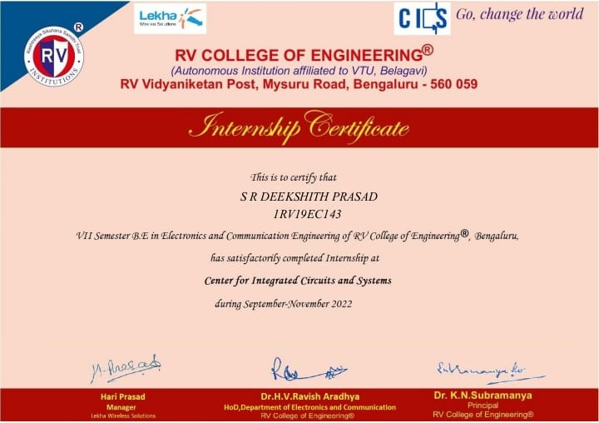

**Certificate of Completion**



**SYNOPSIS**



**CONTENTS**

|  |  |
| --- | --- |
| **Synopsis**  **List of Figures****Abbreviations**  **1 Profile of the organization** | **i**  **iv v 1** |
| 1.1 Introduction . . . . . . . . . . . . . . . . . . . . . . . . . . . . . . . . . . | 2 |
| 1.2 Organization Structure and Research . . . . . . . . . . . . . . . . . . . . | 2 |
| 1.2.1 Research Collaboration . . . . . . . . . . . . . . . . . . . . . . . . | 4 |
| 1.3 Modules in CICS . . . . . . . . . . . . . . . . . . . . . . . . . . . . . . . | 5 |
| 1.4 Courses in Curriculum . . . . . . . . . . . . . . . . . . . . . . . . . . . . | 5 |
| **2 Activities of the Department** | **8** |
| 2.1 Vision . . . . . . . . . . . . . . . . . . . . . . . . . . . . . . . . . . . . . | 9 |
| 2.2 Mission . . . . . . . . . . . . . . . . . . . . . . . . . . . . . . . . . . . . | 9 |
| 2.3 Outcomes . . . . . . . . . . . . . . . . . . . . . . . . . . . . . . . . . . . | 9 |
| 2.4 Value Addition to the Institution . . . . . . . . . . . . . . . . . . . . . . | 10 |
| 2.5 Benefits to the research community . . . . . . . . . . . . . . . . . . . . . | 11 |
| 2.6 MOU’s Signed by the Centre of Excellence . . . . . . . . . . . . . . . . . | 12 |
| **3 Tasks performed** | **13** |
| 3.1 Introduction to Battery Management System in Implantable Devices . . | 14 |
| 3.2 Objectives . . . . . . . . . . . . . . . . . . . . . . . . . . . . . . . . . . . | 14 |
| 3.3 Literature Review . . . . . . . . . . . . . . . . . . . . . . . . . . . . . . . | 15 |
| 3.4 Charge Pump . . . . . . . . . . . . . . . . . . . . . . . . . . . . . . . . . | 19 |
| 3.5 Cross Coupled Charge Pump . . . . . . . . . . . . . . . . . . . . . . . . . | 21 |
| 3.5.1 Working and modelling . . . . . . . . . . . . . . . . . . . . . . . . | 21 |
| 3.5.2 Key Features of Cross Coupled Charge Pump . . . . . . . . . . . | 24 |
| 3.5.3 Simulation . . . . . . . . . . . . . . . . . . . . . . . . . . . . . . . | 25 |
| 3.6 Operational Transconductance Amplifier . . . . . . . . . . . . . . . . . . | 26 |
| 3.6.1 Principle of Operation . . . . . . . . . . . . . . . . . . . . . . . . | 27 |



* + 1. Advantages of Operational Transconductance Amplifier 29
    2. Simulation 29
  1. Oscillator 31
     1. Principle of Operation 31
     2. Simulation 32
  2. Integrated Circuit 33
  3. Simulation of Integrated Circuit 34

1. Reflections 36
   1. Results 37
   2. Learning Outcomes of the Project 37



**LIST OF FIGURES**

1.1 COE-CICS . . . . . . . . . . . . . . . . . . . . . . . . . . . . . . . . . . 3

1.2 Research Activities . . . . . . . . . . . . . . . . . . . . . . . . . . . . . . 5

1.3 Training Program for Students . . . . . . . . . . . . . . . . . . . . . . . 6

* 1. Activities by COE-CICS 11
  2. Modules by COE-CICS 12
  3. Basic Charge Pump Circuit 19
  4. Schematic of a Charge Pump Circuit 21
  5. Single stage cross coupled charge pump with a clock source 22
  6. Timing diagram of cross coupled charge pump 22
  7. Circuit explaining the lost charge parasitics in phase 1 23
  8. Schematic of single stage Cross Coupled Charge Pump 25
  9. Schematic of four stage Cross Coupled Charge Pump 25
  10. Output of Cross Coupled Charge Pump 26
  11. Operational Transconductance Amplifier 27
  12. Output equation Operational Transconductance Amplifier 27
  13. OTA Schematic 28
  14. Schematic of Operational Transconductance Amplifier 30
  15. OTA Transient Analysis 30
  16. A general Ring Oscillator 31
  17. Oscillator Schematic 32
  18. Transient response of the oscillator 33
  19. Integrated Circuit 33
  20. Schematic Diagram of Integrated Circuit 34
  21. DC Analysis plot of Integrated Circuit 34
  22. Plot of output current 35



**ABBREVIATIONS**

**AC** Alternating Current

**AIMD** Active Implantable Medical Devices

**DC** Direct Current **ECG** Electrocardiogram **IC** Integrated Circuit

**IMD** Implantable Medical Devices

**LIB** Lithium Ion Battery

**MOSFET** Metal Oxide Semiconductor Field Effect Transistor

**OTA** Operational Transconductance Amplifier

**PMD** Programmer Monitor Device **PMU** Power Management Unit **PSK** Phase Shift Keying

**UC** Ultra Capacitor

**VCCS** Voltage Controlled Current Source

**WPT** Wireless Power Transfer



**Chapter 1**

**Profile of the organization**



**CHAPTER 1**

**PROFILE OF THE ORGANIZATION**

The internship was carried out for 6 weeks in Centre for Integrated Circuits and Systems which specializes design, analysis, and optimization of digital and analog circuits. With the hardware market booming with the rise of chip-driven products in various fields, the COE offers projects in the areas of Digital, Analog, and Mixed Signal mode VLSI design.

* 1. **Centre for Integrated Circuits and Systems**

The Centre for Integrated Circuits and Systems (CICS) is a research center focused on the study and development of integrated circuit and systems technology. The CoE consists of passionate students and faculty members willing to create an eco-system that inspires the VLSI/Electronics system designer, to nurture the skills and innovative ideas, and to promote sustainable and interdisciplinary research, with inclusive societal con- cerns. The CoE promotes a coherent training program that enhances the skill set of young designers in the specified areas with academia-industry collaboration in India and abroad. The CICS lab in R.V College of Engineering is shown in the Figure 1.1. A center of excellence is a specialized unit or organization within a larger entity that is dedicated to promoting and advancing a specific area of expertise or field of study. CoEs typically focus on research, education, and training, and are designed to bring together leading experts, resources, and technology to support the development and advancement of the field.

It aims at engaging enthusiastic students in design/development activities through funded projects and consultancy works from various organizations thereby contributing to the growth of the nation.

* 1. **Interdisciplinary Research & Innovation**

Interdisciplinary research is a type of study or research that draws from two or more disciplines in order to gain a more well-developed perspective or discover something new. Interdisciplinary research is growing in popularity and is increasingly seen as essential. Multiple perspectives on research challenges will often lead to better outcomes. An inter- disciplinary research center is a facility or organization that brings together scholars and researchers from different disciplines to collaborate on a specific area of study. These cen-



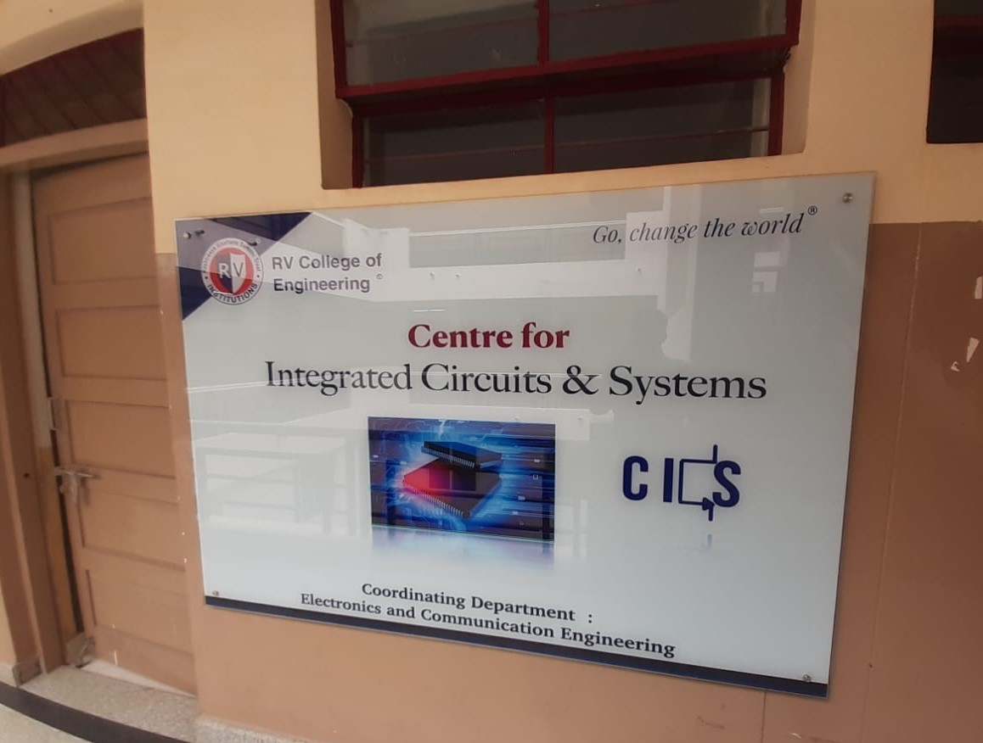ters often focus on cross-disciplinary research projects, utilizing the unique perspectives and expertise of researchers from different fields to address complex issues and problems. In order to streamline and undertaking focused research, the institution has followed the

Figure 1.1: COE-CICS

following approach for execution of funded projects and industrial consultancy. Also to develop competency in students and faculty.

* + 1. Identifying Thematic Areas of Research: Carrying out SWOC analysis of the insti- tution and aligning goals inline with Thrust areas of Govt. & Industry is helping identifying need based areas of research. Thrust areas are identified through road maps, govt. policy documents, Vision 2035, UN SDG 2030, funding agency require- ments and such others.
    2. Aligning with existing infrastructure and identifying new infrastructure needed: The institution has separate PG / Research budget to cater to new equipment’s and seed funding for students and faculty. Many companies and funding agencies have helped in establishing physical infrastructure and state of the art equipment and software are provided over a period of time
    3. Assigning Team: Based on the specialization and competency of the faculty, vari-



ous interdisciplinary teams are formed to undertake need based research, execute projects and consultancy assignments.

* + 1. Developing Modules and providing training: The newer areas of science and tech- nologies need learning through training from experts. Based on the need of the faculty, training in thematic areas are provided through institutional funding and providing seed funding for initial experimentation & Simulation, wherever needed. Mentoring by Industry & Research Experts in the thematic areas are also taken up for better understanding of the need and execution.
    2. Executing work as per standards: Funding agencies and industries expect deliv- erables in terms of products, processes and systems, which are scalable. Efforts are made to execute the projects and consulting work based on the goals set and measured through publishing in peer reviewed journals, developing prototypes and and obtaining Patents and copy rights.
    3. Reporting periodically & Scale Up the CoE / CoC: Documentation of the work carried out and submitting to the agencies is a continuous assignment and also helps future work to be undertaken. The whole exercise of interdisciplinary research and innovation is also helping in developing incubation center and Start-ups for commercialization of IPs, and alternate Revenue generation for sustainability.

**1.2.1 Research Collaboration**

The center is well equipped with trained faculty, computational infrastructure and necessary teaching learning softwares both open source and commercial. The various research activities by held by the CICS is shown in the Figure 1.2. It involves research activities, consultancy projects, ideations, internship oppurtunities and train the trainee programs.

The training program conducted for students by the department for research purposes with commercially licensed software and one of the Invited talks, delivered by Mr. Prakash Bettadapur on the topic “Product Engineering and Agility- An overview” for the students to catch up on the latest and advanced technologies at the Industry level is shown in the Figure 1.3. The CoE also aims at providing more training and research programs for the development of students.



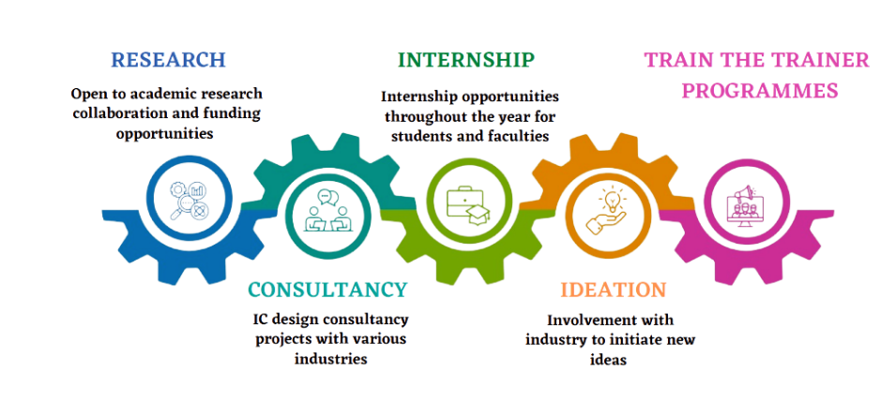

Figure 1.2: Research Activities

* 1. **Modules in CICS**

Various Modules in Analog Design :

* + 1. Introductory course on Analog IC Design with hands on using simulators
    2. Op-amps for everyone - with hands on simulators
    3. Design of low power analog modules with bias generation with hands on using simulators

Various Modules in Mixed Signal IC Design :

1. Introductory course on Mixed signal IC Design with hands on using simulators
2. Data converters for everyone - with hands on using simulators
3. Design of ADC/DAC Architectures from specifications with hands on using simu- lators
   1. **Courses in Curriculum**

The circuit branches of Electronics and Communication Engineering, Electrical and Electronics Engineering, Electronics and Instrumentation, Electronics and Telecommu- nication have the foundation courses in the areas of IC Design in the curriculum so that any student from circuit branch can make use of the facility available in the centre. The





Figure 1.3: Training Program for Students

curriculum of Electronics and Communication Department has the specialised courses of the centre as core and electives. This will bring in momentum to the activities in the centre.

UG Courses

* Analog Microelctronic Circuits
* Analog Integrated Circuit Design
* Radio Frequency and Millimeter Wave IC Design
* Mixed Signal IC Design PG Courses
* Analog Integrated Circuit Design
* Radio Frequency IC Design



* Digital VLSI Design
* VLSI for Testing and Testability

The chapter explained the profile of the organization, the research facility provided to the students under the guidance of experienced faculty for the betterment of student’s perspective on upcoming latest technologies with innovative and inspiring Talks in an Industry level. The next chapter discusses about the activites of the department, possible outcomes by the Internship, various modules and Industry level projects in commercial licensed softwares, also discuss the different MOU’s signed by COE with the Industries for the welfare of students.

.



**Chapter 2**

**Activities of the Department**



**CHAPTER 2**

**ACTIVITIES OF THE DEPARTMENT**

This chapter focuses on the activities of the department, Center of Excellence in Circuits and Integrated Systems (CICS), R.V. College of Engineering. It puts forward the Vision, Mission, Objectives, Outcomes, Benefits of the Organization to the research community, MOU’s signed by COE-CICS.

* 1. **Vision**

Creating an eco-system that inspires the VLSI/Electronics system designer, nurturing their skills and innovative ideas, promoting sustainable and interdisciplinary research, with inclusive societal concerns.

* 1. **Mission**
     + To create an eco-system for ultra-low power analog, mixed signal, RF and power management services and realise their benefits to society in near future.
     + To promote a coherent programme of training which will enhance the skill set of underprivileged people in the specified areas with academia - industry collaboration in India and abroad.
     + To engage in design/development activities by carrying out funded projects and consultancy works for various organisations and thereby partake in the growth of the nation.
     + To establish as a stand-alone centre which can attract people from various domains and leverage substantial interdisciplinary research.
  2. **Outcomes**
     + Engage in fabless design of various IP blocks for Analog ICs / Mixed Signal ICs / RFICs / Memory / Digital ICs / SoCs/ASICs.
     + Train students and faculty across India in the areas of Analog ICs / Mixed Signal ICs / RFICs / Memory / Digital ICs / SoCs/ASICs.
     + Engage in R&D projects in the areas of Analog ICs / Mixed Signal ICs / RFICs

/Memory / Digital ICs / SoCs/ASICs.



The activities under the proposed Centre can be categorized in 2 groups.

1. Provide industry-certified internships for UG/PG students throughout the year for all 3 modules in the areas of IC Design
   * Fundamental module (1st and 2nd sem UG students of all circuits branches)
   * Intermediate module (3rd and 4th sem UG students of all circuits branches, 1st sem PG students of VLSI/Communication Branch)
   * Advanced module (5th and 6th sem UG students of all circuits branches, 2nd and 3rd sem PG students of VLSI/Communication Branch)
2. Execute consultancy projects with the companies that we have tied up with. This will help PG/UG students to work on industry-related projects which will give them better exposure to the state of the artwork. Apart from regular workshops, the center can float specialized certificate programs in various areas of IC Design in the following years as it is in huge demand. The specialized certification programs can be run in online/offline mode with 3 Core courses and 2 Elective courses, with capstone projects. The center will focus on a handful of activities in the future as shown in Figure 2.1

The specialized certification programs can be run in online/offline mode with 3 Core courses and 2 Elective courses, with capstone projects. The center will focus on a handful of activities in the future as shown in Figure 2.1 and Figure 2.2.

* 1. **Value Addition to the Institution**

The COE brings value addition to the institution.

1. By enhancing research, consultancy works in the proposed themes and domains.
2. By offering training programs to students of all disciplines from the various modules offered by the center and can carry out design projects in the center.
3. Through funded projects from public and private sectors.
4. By promoting PG and full-time Ph.D. through research activities.
5. By offering value addition to the degrees offered by the institution through projects, training programs, workshops, and symposiums.



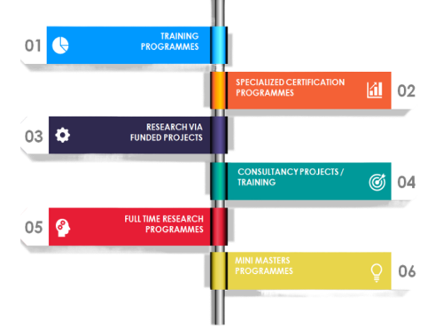

Figure 2.1: Activities by COE-CICS

1. Fabricated chips will be added to the chip gallery of the center which can elevate the center to a hub for IC Design.
2. The quality of the students and innovative ideas developed in the institution adds a significant status for the institution in the community.
   1. **Benefits to the research community**

The center provides benefits to the research community in the following ways.

* + - Students / Faculty, both internal and external, can take up structured training programs to enhance the research activities.
    - Research scholars can use the facility of the center for their research.
    - Encourages students to publish papers in Journals.
    - Support students and faculties to attend and present their paper in International/ National Conferences.



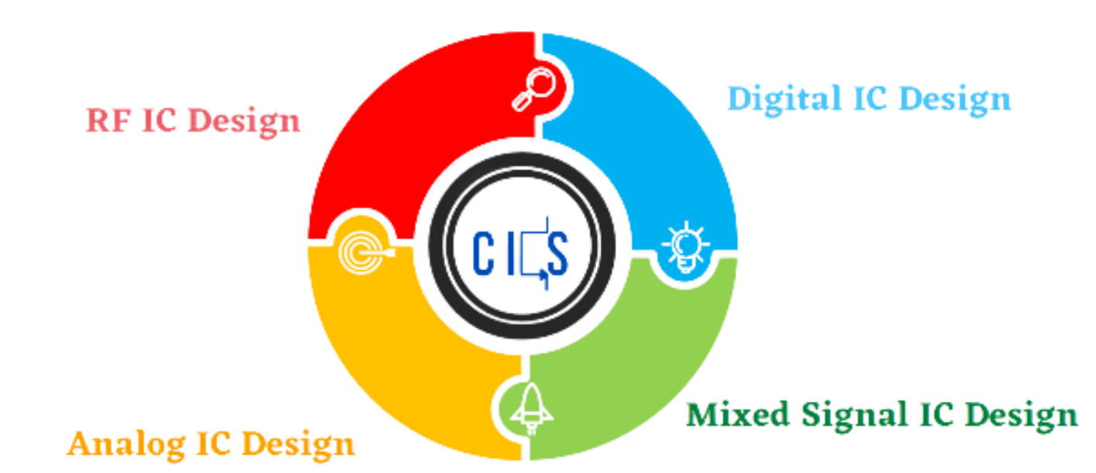

Figure 2.2: Modules by COE-CICS

* + - Motivate students to take up Industry level projects and update to the current status.
  1. **MOU’s Signed by the Centre of Excellence**

The centre has signed an MOU with

1. Entuple technologies to assist the centre with fabless design. This will be done by the experts in the appropriate field from entuple technologies.
2. Lekha Wireless solutions offers consultancy projects and internships to the students from RVCE.
3. WPIF offers internships to students.
4. SCL technologies offered 180nm PDK (a commercial library) for Cadence Virtuoso.

The chapter briefed about the possible outcomes from the internship with Industry level projects, benefits to the research community and value added to the institution with a possible publication and innovative projects carried out by the students for the welfare of community, adding a significant status to the Institution. The next chapter views on the tasks performed in the Internship followed by the obtained learning outcomes of the Internship.



**Chapter 3**

**Tasks performed**



**CHAPTER 3**

**TASKS PERFORMED**

This chapter includes all the tasks performed in the internship and discusses the objectives, design, implementation and results compared with expected outputs.

* 1. **Introduction to Battery Management System in**

**Implantable Devices**

Wearable electronics are small electronic devices worn by a person to provide intelli- gent assistance. They can be implanted inside the body, and can be worn externally. A medical device is defined as implantable if it is either partly or totally introduced, surgically or medically, into the human body and is intended to remain there after the procedure[1]. Implantable devices, usually sensors, are widely used in various biomedical applications. An important factor about such a device is to function without a plugged in power source. Usually batteries are used to power such devices - rechargeable or non rechargeable. Rechargeable batteries need an external energy source whereas non rechargeable batteries have to be replaced peri- odically and replacing them exposes an individual to unnecessary dangers as biomedical implants operate in environments which are not easy to access. Hence the idea of self powering such devices came to light using small energy sources which harvest energy using the physical processes occurring in the organs. Harnessing energy by such means requires sophisticated circuitry which has to produce sufficient power and also fit in a limited space[2]. Various energy harvesting and charging techniques have been introduced by many researchers over a period of time such as using piezoelectric devices to harvest charges due to vibrations and utilising it for charging the battery, using electrostatic devices and so on. A few designs of the battery charging circuit carry out wireless charging of the battery in the device. The proposed design focuses on charging the battery appropriately with harvested so that the implant functions at its normal capacity.

* 1. **Objectives**

The objectives covered during the course of the internship were as follows

* + 1. To design a charge pump circuit to boost the low voltage obtained from the har- vesting system.



* + 1. To design an operational transconductance amplifier for the required specifications to provide constant current.
    2. To design a charge transfer circuit to transfer the harvested energy to an interme- diate storage device.
  1. **Literature Review**

Literature survey forms an integral part of any project. After surveying various publi- cations, including journals and papers from several sources, it was concluded that charge pump and operational transconductance amplifier will be used in the final integrated circuit. The paper [3] summarizes the issues and challenges related to power implantable devices. The authors have outlined the performance and power constraints of existing biomedical devices and provided a brief overview of various power architectures. Power implantable devices, such as pacemakers and cochlear implants, rely on batteries to func- tion. These batteries have limited lifetimes and will eventually need to be replaced, which can be a complicated and invasive procedure for the patient. Usage of charge pump for voltage amplification is defined. Authors also mentions that Dickson charge pump can be used as Voltage amplifier for cardiac stimulator.

The results of paper [4] infers the use of Voltage Controlled Current Source (VCCS) for the charging of the battery. Authors have also mentioned that usage of Operational Transconductance Amplifier (OTA) as VCCS increases efficiency and consumes less area. The trade-off with battery lifetime as to whether such devices employ a primary cell or rechargeable battery is also discussed. In the context of charging a battery, a VCCS can be used to control the rate at which the battery is charged. By adjusting the voltage applied to the circuit, the VCCS can increase or decrease the current flowing through the circuit, thus controlling the charging rate of the battery. This can be useful in situations where the battery needs to be charged at a specific rate The application and advantages of rechargeable batteries for implantable medical devices is discussed in this paper.

In paper [5], authors have discussed the performance requirements and performance of different secondary battery topologies that can be used to store harvested charge and recharge the Implantable Medical Devices (IMD)s. Secondary batteries based on Lithium Ion chemistry have also been developed for medical applications where the batteries are charged while remaining implanted. While the performance requirements and thus the



battery power delivery vary, some general characteristics are common for all batteries used in medical devices. These include high reliability and volumetric energy density, long service life, state of discharge indication, and safety during implant and in use.

In paper [6], authors have reported that Lithium Ion batteries can be used to charge IMDs. A comparison between different topologies are made and from the results it is said that Lithium Ion batteries are better. The discharge voltage is three times better than the nickel cells. Measuring the remaining voltage in the battery is easier, thus providing enough time to change the battery for IMDs. It will be enough to make implants to work for several years.

The results given in paper [7] prove that the mechanical energy in vibrations, which are naturally abundant in many practical applications, can be scavenged and channeled to a rechargeable battery. The proposed system in the paper extends the operational life of the system indefinitely without any external replacement of the battery or manual recharging.

The results in the paper [8] prove that for the storage of harvested energy, and to optimize energy storage, a combination of two different technologies should be used, i.e Lithium Ion Battery (LIB) and Ultra Capacitor (UC). And therefore, the limitation of available power density in LIB and higher self discharge in UC can be overcome. This can act as a hybrid storage system where LIB helps in longer storage of charge and UC takes over short term absorption of higher power amounts. The energy generated can temporarily be stored in UC, then transferred to LIB via DC-DC converters. But with further research it is observed that, using UC in implantable devices is not a feasible option because of the huge size of UC.

In the paper [9], existing issues and challenges related to current solutions used for harvesting energy to power implantable devices are discussed. In addition, the details on existing energy storage technologies. The internal part consists of an AC-to-DC rectifier, a Power Management Unit (PMU), a charge pump, and a Phase Shift Keying (PSK) demodulator with clock and data recovery. A modified Dickson charge pump is adopted to generate high pumping voltage (3.2V) for the cardiac stimulator.

The paper [2] describes an ultra-compact analog Lithium-Ion battery charger with high energy efficiency. The charger presented here utilizes the tanh basis function of a sub-threshold operational transconductance amplifier to smoothly transition between



constant-current and constant-voltage charging regimes without the need for additional area- and power-consuming control circuitry. The design works on the principle of con- stant current constant voltage method of charging. The proposed design operates in the current domain, eliminating the need for precision-trimmed sense resistors to determine the end-of-charge point, reducing layout area, manufacturing complexity, and potential charging error due to resistor mismatch.

In paper [10],it has a two battery based power management system. It consists of a supply detector and a charge detector for facilitating the power management. A charger circuit is employed to provide a constant current to charge the batteries. A low-power, wireless, and implantable micro stimulator system on chip with smart powering manage- ment, immediate neural signal acquisition, and wireless rechargeable system is proposed. In paper [1], methodologies to transfer and harvest energy in implantable medical devices are introduced and discussed to highlight the uses and significance of various potential power sources. A wireless rechargable system for a pacemaker would involve a device that is implanted in the patient’s chest, similar to a traditional pacemaker. However, instead of requiring surgery to replace batteries, the device would be recharged wirelessly through the use of a charging pad or similar device. The charging pad would be placed on the patient’s skin over the pacemaker and would transmit energy to the device through electromagnetic waves. This would eliminate the need for invasive battery replacement surgeries and would allow for more convenient and efficient maintenance of

the pacemaker.

In [11] the author describes the various mechanisms by which electrostatic harvest- ing happens, these are: Charge constrained systems, Voltage constrained systems and Electret based capacitors. The charge constrained system while easy to implement poses the problem of very high voltages which cannot be sustained by an Integrated Circuit (IC). The electric system is also efficient but requires expensive material which makes it impractical to manufacture. Hence, the voltage constrained system is adopted.

The paper [12] aims at improving wireless security during the communication between IMD and Programmer Monitor Device (PMD). The main objective is to prevent physi- cal substitution/cloning assaults by integrating low-complexity, durable digital physical identities into the system hardware. The security system is supported by a biometric identification that includes a relatively difficult-to-clone patient personal health profile



that is taken from the patient’s Electrocardiogram (ECG). This biometric identification is extracted using a machine learning technique. The proposed approach first produced practical accuracy in deriving the biometric identity that was close to 95 percentage.

The paper [13] discusses about the design of micro-device integrated antennas suitable for energy harvesting applications. Implantable devices are becoming smaller and smaller, making possible new solutions for the current challenges in medical diagnosis, treatment and monitoring. The implantable solutions rely on miniaturized devices that can be controlled and powered via wireless communications.

The paper [14] discusses about various methods to power up the implants. Many techniques like thermal, electrostatic and piezoelectric techniques have been discussed and piezoelectric is decided as optimal solution. Implant’s designs tend increasingly to the miniaturization (micro/ nanotechnology) in order to be more bio compatible and comfortable. Any time the implant needs energy to function properly.

The paper [15] discusses the ability to generate energy from the human body without using any external power source by using a piezo-element sensor.The piezo-element is designed to be mounted to the patient’s shoes, and energy is generated from the pressure applied to the sensor while the patient walks. The generated energy is used to power an implantable medical device’s battery. Wireless transmission occurs with low risk to the patients’ lives.

In paper [16], inductive power transmission for a closed loop wireless implantable brain machine interface is described. The system is created to guarantee optimal power transfer from a battery-operated off-body unit to an implanted unit inside the body, while also guaranteeing a minimum transmitted power level for proper operation and a maximum level to prevent brain tissue damage due to implanted electronics overheating. A minimum power of 20 mW is given to the implanted unit.

The Paper [17] implements a battery charge meter, to monitor the battery life. The output voltage of the implemented circuit may steeply drop during the end of life of the battery. Also, a switched capacitor voltage controlled oscillator is implemented. Since the IC consumes less power, it is expected to increase the lifetime of the device used in biomedical applications. It also discusses about the different power issues faced in different battery topologies.

The Paper [18] explains different types of Active Implantable Medical Devices (AIMD),



their life and size of the battery and in turn size of AIMDs and ways to overcome the problems. Recharging the battery wirelessly is the optimal solution to limit the surgical insertion of the device for the second time i.e. to replace the AIMD. As well as recharge- able battery may reduce the size of AIMD as half of the size of pacemaker is occupied by battery. This paper also explains about the different compensation techniques to imple- ment Wireless Power Transfer (WPT) system to increase efficiency of power transfer.

After conducting thorough literature survey on various research publications, it was concluded charge pump can be used to boost the low voltage obtained from the energy source and an OTA is used to generate constant current to charge the battery. The comparison of various battery topologies suggests that Lithium ion batteries are suitable for power source for implantable medical devices.

* 1. **Charge Pump**

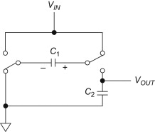For a implantable device like a pacemaker, there should be continuous and uninter- rupted supply of power, so that it will function correctly. The constant current must be maintained all the time. The battery needs to be recharged periodically from an external source which is a complicated process or use the available energy source present nearby like the vibration energy, solar energy, thermal energy etc. to replenish the charge. The voltage obtained from such a source is very small, in the range of mili Volts or even lesser. Therefore there is a requirement of a DC - DC step up converter which generates higher voltage using the available low voltage.

Figure 3.1: Basic Charge Pump Circuit

In devices, conversion of available Direct Current (DC) voltage into higher or lower voltage is important. In Alternating Current (AC) signals, a transformer can be used for both up conversion and down conversion. For converting a high DC voltage to lower DC voltage, devices like buck converter or Low Drop-out Regulator can be used. But



converting a low DC voltage to high DC voltage is not simple. These are divided into two types depending on how the conversion is performed: magnetic and capacitive convert- ers[19]. A rectifier and filter can be used in addition to the transformer to get a regulated output, however, this increases the complexity and the size of the circuit. Since the inte- grated inductors occupy a large area and often have a limited quality factor, only DC-DC switched-capacitor also called charge pumps are considered here. Charge pumps have become an excellent alternative to this and are also considered IC friendly [20]. A charge pump circuit, or charge pump regulator represented in Figure 3.1, is a kind of DC-DC converter that leverages switched-capacitor techniques to either increase or decrease an input voltage level. Charge-pump circuits are capable of high efficiencies, sometimes as high as 90–95 percentage, while being electrically simple circuits. A charge pump is a type of electronic circuit that is used to increase or decrease the voltage of a power sup- ply. It works by using a series of switching elements (such as diodes and transistors) to convert a lower voltage input into a higher voltage output. Charge pumps are commonly used in applications such as DC-DC converters, power inverters, and voltage regulators. They can also be used to generate high voltage pulses for use in applications such as electrostatic discharge protection and LCD back lighting. Charge pumps use some form of switching device to control the connection of a supply voltage across a load through a capacitor. In a two stage cycle, in the first stage a capacitor is connected across the supply, charging it to that same voltage. In the second stage the circuit is reconfigured so that the capacitor is in series with the supply and the load. This doubles the volt- age across the load - the sum of the original supply and the capacitor voltages. The pulsing nature of the higher voltage switched output is often smoothed by the use of an output capacitor [21]. An external or secondary circuit drives the switching, typically at tens of kilohertz up to several megahertz. The high frequency minimizes the amount of capacitance required, as less charge needs to be stored and dumped in a shorter cycle.

The circuit blocks generally consist of capacitors and switches (i.e clock-controlled field-effect transistors) and work by timing and controlling these switches to exploit the charge transfer characteristics of capacitors as shown in the Figure 3.2. Discrete de- signs use diodes rather than transistors to implement the required switching operation. Through alternatively charging and discharging capacitors, a charge pump can increase or decrease a given input voltage to the desired level.



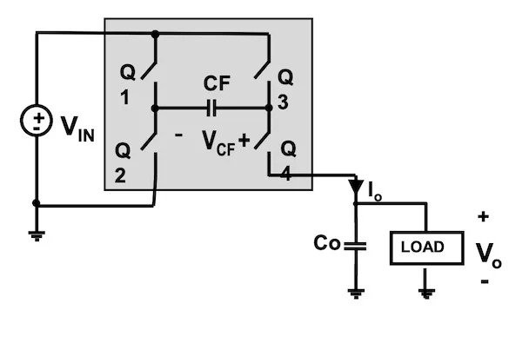

Figure 3.2: Schematic of a Charge Pump Circuit

Charge pump circuits work on the basic principle that the voltage across a capacitor cannot change instantaneously. As defined by the capacitor I-V equation, in order for a capacitor to change its voltage instantaneously, it would require an infinite amount of current. Since this is not physically possible, a capacitor cannot abruptly change the voltage across its terminals. Charge pumps work to exploit this behavior in order to manipulate the voltage across a capacitor through the use of carefully timed switches.

* 1. **Cross Coupled Charge Pump**

All of the components in the circuit Figure 3.3, which is precisely symmetrical, have the same characteristics. There are two provided complimentary clocks with amplitude *VDD*.

A cross-coupled charge pump is a circuit that uses a pair of cross-coupled transistors to convert a low voltage DC input into a higher voltage DC output. The circuit works by repeatedly charging and discharging a capacitor, using the transistors to switch the voltage on the capacitor between the input voltage and a higher voltage level. The output voltage is the sum of the input voltage and the voltage on the capacitor. This circuit is often used in electronic devices to generate a higher voltage from a lower voltage source.

* + 1. **Working and modelling**

The principle of cross-coupled charge pump refers to a circuit design that uses two or more capacitors that are connected in a specific way to increase the output voltage and current of the circuit. This is achieved by connecting the capacitors in a ”cross-coupled”



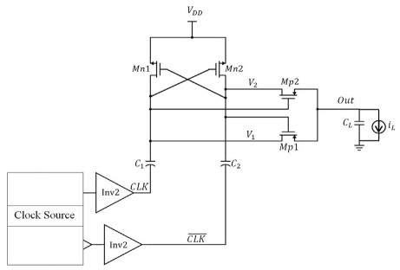configuration, where the positive terminal of one capacitor is connected to the negative terminal of another capacitor, and vice versa. This creates a ”pumping” effect that allows charge to be transferred from one capacitor to the other, increasing the overall voltage and current output of the circuit. This charge pump topology’s operation can be split into two sections. Phase 1 sees CLK high and *clk′* low; phase 2 sees the opposite. Phase 2 begins with the output at 2*VDD*, nodes V1 and V2 at 2*VDD* and *CDD*, MP1 turned on and MP2 off, respectively. Phase 1 of the circuit is entered when CLK goes from low to high. In order to turn MN2 off, node V1 is discharged to *VDD*, and in order to turn MN1 on, node V2 is raised to 2*VDD*. This series of actions turns MP2 ON and MP1 OFF, resulting in an output voltage of 2*VDD*.

Figure 3.3: Single stage cross coupled charge pump with a clock source

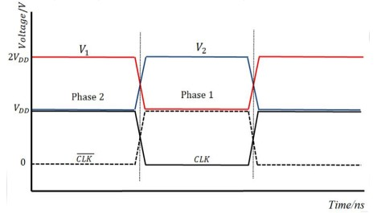

Figure 3.4: Timing diagram of cross coupled charge pump

The phase 2 involves switching the functions of MN1 and MN2, as well as MP1 and MP2, resulting in a constant voltage of 2*VDD* at the output. The details this entire



procedure is shown in Figure 3.4. Phase 1 of the circuit is entered when CLK is low, turning off MN2. There is nowhere for the current or charge to flow out (since MN2 and MP2 are still OFF and there are no parasitics connected to node V2) as CLK moves to *VDD*, thus the charge stored in C2 must be conserved. As a result, the voltage at C2’s top plate is increased to 2*VDD*.

When a load or parasitic load is assumed to be absent, it is determined that the charge held in capacitor C2 during phase 2 is provided by:

*Qph*2 = *C*2 ∗ *VDD* (3.1)

In the phase 1 of the circuit is entered when CLK is low, turning off *MN*2. There is nowhere for the current or charge to flow out (since *MN*2 and *MP*2 are still OFF and there are no parasitics connected to node V2) as CLK moves to *VDD*, thus the charge stored in C2 must be conserved. As a result, the voltage at *C*2’s top plate is increased to 2*VDD*.

As a result, one can see that a single stage charge pump’s output node always has 2*VDD* voltage present throughout the whole operating period. Consider the parasitic capacitances at node *V*2 (originating from the top plate of *C*2, the gate of *MP* , *MN*1, and the drains of *MP* , *MN*2); a charge flow is required to raise the voltage of these parasitics over *VDD*. This charge originates from C2 since MN2 and MP2 are OFF, which causes a charge loss and voltage drop. The following diagram Figure 3.5 illustrates how the current flowing to the parasitics and the drop in voltage (*Vlost*) are represented:

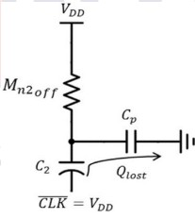

Figure 3.5: Circuit explaining the lost charge parasitics in phase 1



There are four transistors in single stage in cross coupled charge pump and when four stages are combined, there are 16 transistors.

* + 1. **Key Features of Cross Coupled Charge Pump**
       1. Dual Output Voltage: A cross-coupled charge pump typically generates two output voltages, one being the inverted version of the other.
       2. High Efficiency: The cross-coupled charge pump design allows for efficient voltage conversion, resulting in less power consumption and heat dissipation.
       3. Low Noise Operation: The cross-coupled charge pump circuit is designed to mini- mize noise and ripple in the output voltage, resulting in a stable and clean power supply.
       4. High Current Output: The cross-coupled charge pump can deliver high current output, making it suitable for applications that require high power output.
       5. Low Voltage Input: The cross-coupled charge pump can work with low input volt- age, making it suitable for battery-powered applications.
       6. Low External Component Count: The cross-coupled charge pump circuit typically requires fewer external components, making it easy to implement in a circuit.
       7. High Switching Frequency: The cross-coupled charge pump circuit can operate at high switching frequencies, which can result in high output voltage and high efficiency.
       8. Adaptable to Different Applications: The cross-coupled charge pump circuit can be adapted to different applications by varying the number of stages, the capacitance of the capacitors, and the switching frequency.
       9. Enhanced Power Output: The cross-coupled design allows for a higher output power, making it suitable for applications that require more power than a tra- ditional charge pump can provide.
       10. Reduced Ripple: The use of two stages in a cross-coupled charge pump helps to reduce ripple, providing a cleaner output voltage.



* + 1. **Simulation**

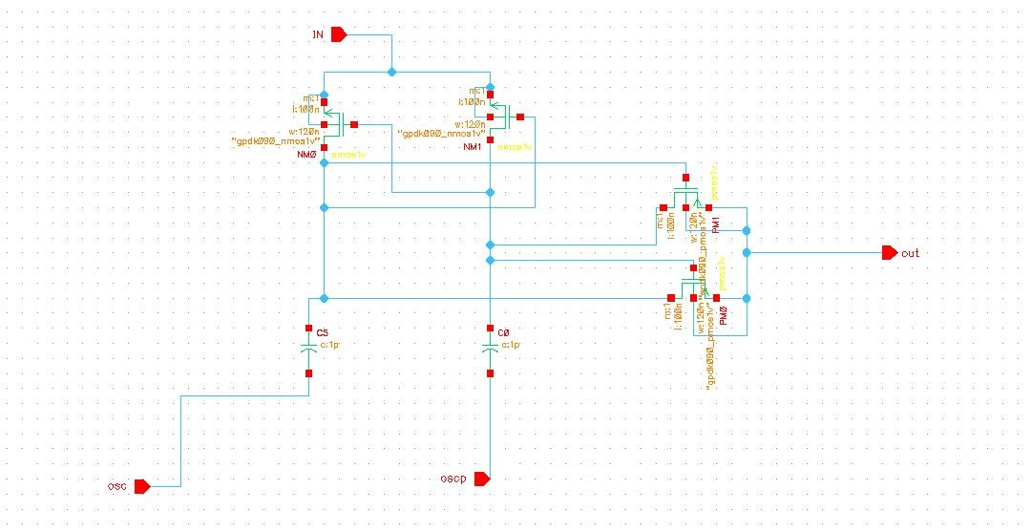

Figure 3.6: Schematic of single stage Cross Coupled Charge Pump

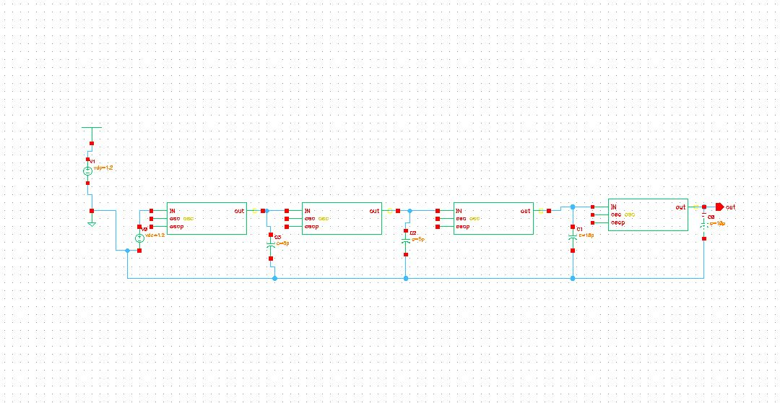

Figure 3.7: Schematic of four stage Cross Coupled Charge Pump

The four stage schematic of cross-coupled charge pump in transistor level is repre- sented in Figure 3.6 and Figure 3.7. The transient response with a current plot along with output voltage is shown in Figure 3.8. The circuit produces an output voltage of



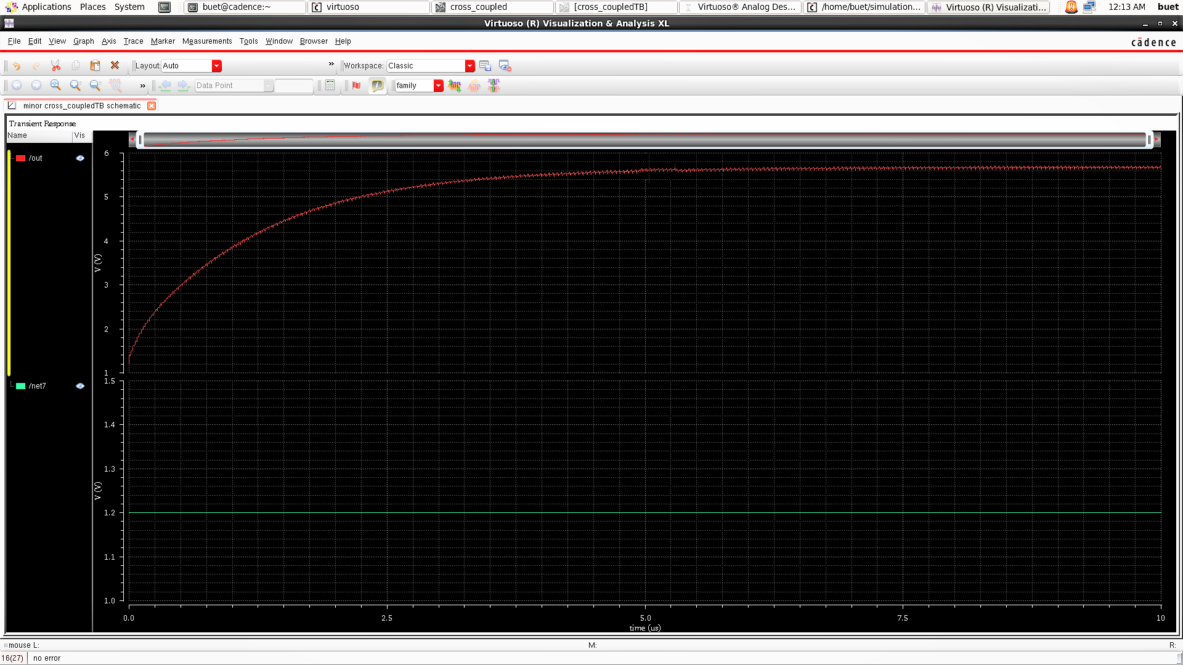4.3055 V for an input voltage of 1.8 V. The voltage increases exponentially initially and saturates after a while.

Figure 3.8: Output of Cross Coupled Charge Pump

* 1. **Operational Transconductance Amplifier**

The operational transconductance amplifier is an amplifier whose differential input voltage produces an output current. Thus, it is a VCCS. There is an additional input for a current to control the amplifier’s transconductance. The OTA is similar to a standard operational amplifier in that it has a high impedance differential input stage and that it may be used with negative feedback.

In the design, the main problem faced was low current from the charge pump. The value of that output current was very low. To overcome this challenge, OTA is used. Unlike the operational amplifier the output impedance of an OTA approaches infinity. This can be best used to describe the forward gain. It’s basic operation is like a differential amplifier with noise cancellation properties. It also has a capacitive load, which acts as a short circuit and helps in filtering the high frequency noises. The performance of the OTA impacts the overall power consumption and voltage gain. An operational transconductance amplifier is a type of integrated circuit that functions as an amplifier with high voltage and current gain. It is designed to convert a small input current into a large output voltage or current. The OTA is commonly used in applications such as



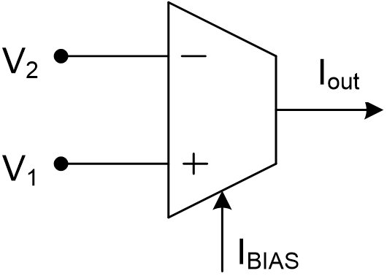audio processing, active filters, and power management circuits. It is characterized by its high input impedance, low output impedance, and high bandwidth. The OTA is typically used in circuit designs that require a high level of precision and stability.

Figure 3.9: Operational Transconductance Amplifier

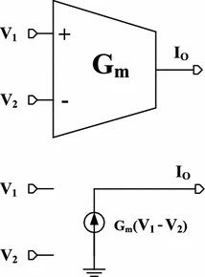Representation of an ideal OTA is given in the Figure 3.9. V1 is positive voltage and V2 is negative voltage. Ibias is the external current source. Output current is represented as Iout. Output will be determined by the difference in input voltages. The

Figure 3.10: Output equation Operational Transconductance Amplifier output current of an OTA can be defined by the Equation 3.2.

*Iout* = *Gm* ∗ (*V*1 − *V*2) (3.2)

where, Gm is transconductance of the amplifier.

* + 1. **Principle of Operation**

An operational transconductance amplifier (OTA) is an electronic circuit that ampli- fies the current flowing through it. The OTA works by controlling the amount of current



flowing through the input terminals, which in turn controls the amount of current flowing through the output terminals.

The OTA circuit consists of an input stage, a control stage, and an output stage. The input stage consists of an input transistor that receives the input current and converts it into a voltage. The control stage consists of a control transistor that controls the flow of current through the input stage. The output stage consists of an output transistor that amplifies the current flowing through the input stage and delivers it to the output terminals.

The OTA operates on the principle of negative feedback, where the output current is fed back to the control stage and used to adjust the input current. This allows the OTA to maintain a constant output current despite changes in the input current.

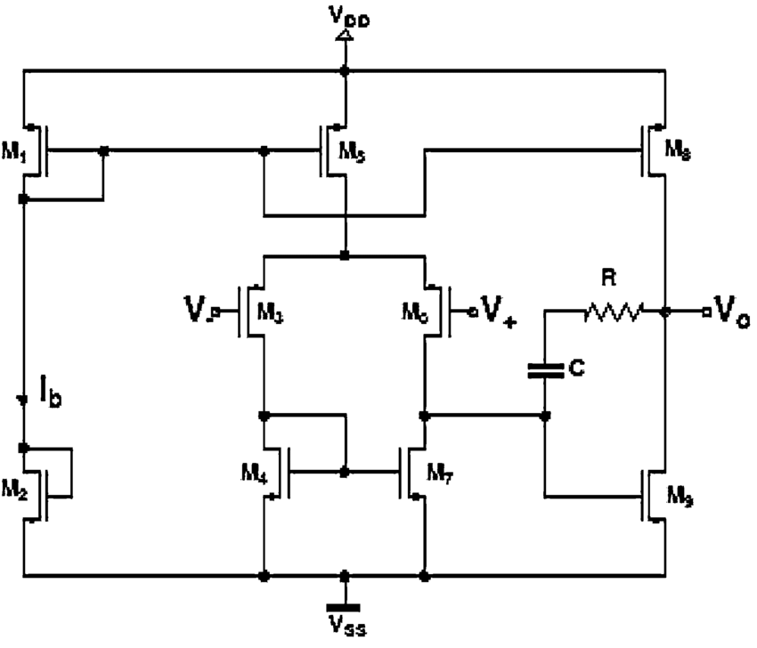The OTA can also be used to control the output voltage by varying the input current. This makes it a versatile circuit that can be used in a variety of applications such as audio amplification, power amplification, and voltage regulation. The operational transconduc- tance amplifier amplifies the current flowing through it by controlling the amount of current flowing through the input terminals, which in turn controls the amount of cur- rent flowing through the output terminals, using negative feedback and input current variations for output voltage control. The principle of an operational transconductance amplifier is to convert an input voltage into a current output.

Figure 3.11: OTA Schematic

The circuit in Figure 3.11 represents the circuit diagram of OTA in the telescopic



configuration. The inputs in this configuration can be given as a differential input, but in order to simplify it, only the positive input terminal is made use of, and the negative terminal is grounded. If a set of transistors are operating in the saturation mode as a transistor pair, then one leg of the transistors will turn on at a particular time while turning the other off. From one leg the current will sink from the load while the current will be sourced to the output from the other leg. The differential input is applied across the gate of PM2 and PM3. An external DC source is used in order to control the transconductance of the amplifier. The transistors in this configuration are arranged in a stacked manner one on top of the other which enhances the output impedance and thus the gain. This OTA also provides lower power consumption and a higher speed [22].

## Advantages of Operational Transconductance Amplifier

* + - 1. High Gain: The operational transconductance amplifier (OTA) has a high gain, making it ideal for applications where a high level of amplification is required.
      2. Wide Dynamic Range: The OTA has a wide dynamic range, which allows it to operate over a wide range of input signals without distortion.
      3. Low Noise: The OTA has a low noise level, making it suitable for applications where low noise is required, such as in audio and communication systems.
      4. High Input Impedance: The OTA has a high input impedance, which allows it to be used with a wide range of input sources without loading them down.
      5. High Output Impedance: The OTA has a high output impedance, which allows it to drive a wide range of loads without affecting its performance.
      6. High Bandwidth: The OTA has a high bandwidth, making it suitable for high- frequency applications such as in radio frequency (RF) and high-frequency commu- nication systems.

## Simulation

The transistor level implementation of the circuit is given in the Figure 3.12 and the Figure 3.13 provides the transient response of the OTA, with an input voltage of 5.8V.



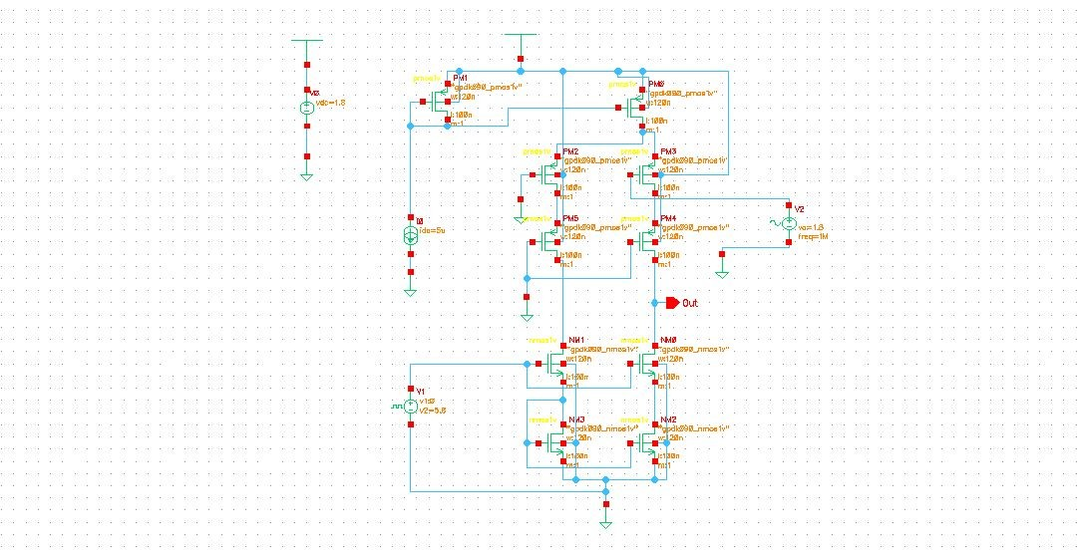

Figure 3.12: Schematic of Operational Transconductance Amplifier

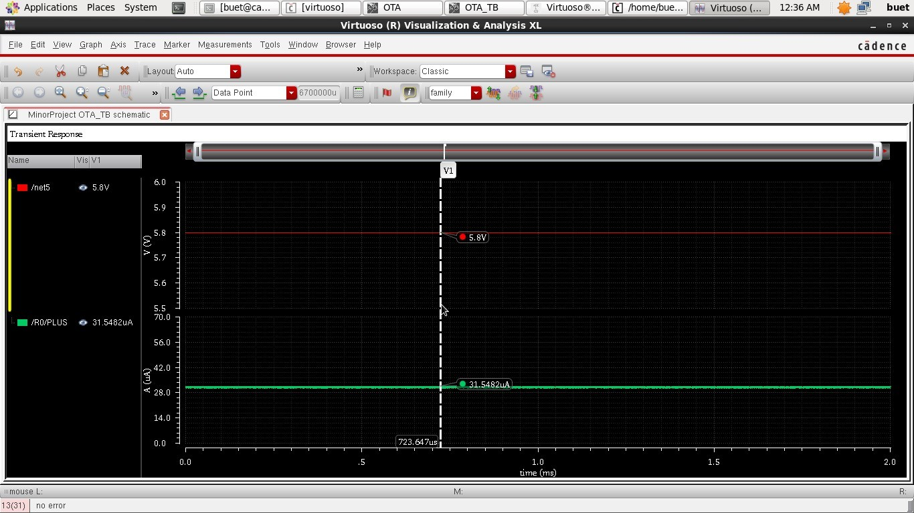

Figure 3.13: OTA Transient Analysis

From the graph, it can be interpreted that the output current is 24.1578 uA. Cascode configuration of OTA is used in the integrated design as it is an improvised version of an OTA when compared to the current mirror and single stage cascode configurations.



# Oscillator

A NOT gate based ring oscillator is a type of electronic circuit that uses a series of inverting logic gates (not gates) to create an oscillating signal. A NOT gate based ring oscillator is designed to get the oscillating signal. This signal has to be fed as clock source for the charge pump. A general ring oscillator schematic using NOT gate is shown in Figure 3.14.

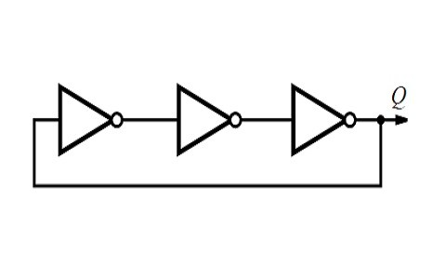

Figure 3.14: A general Ring Oscillator

## Principle of Operation

A ring oscillator is a device composed of numbers of NOT gates in a ring, whose output oscillates between two voltage levels, representing true and false. The NOT gates, or inverters, are attached in a chain and the output of the last inverter is fed back into the first. The ring oscillator is a combination of inverters connected in a series form with a feedback connection. And the output of the final stage is again connected to the initial stage of the oscillator.The principle of a ring oscillator is to use a chain of inverting amplifiers connected in a closed loop, or ”ring,” to create a continuous oscillation. The output of the first inverter is fed back to the input of the last inverter, creating a feedback loop. The inverters act as phase shifters, with each inverter shifting the phase of the input signal by 180 degrees. The resulting signal is a square wave oscillation that is determined by the number of inverters in the ring and the propagation delay of each inverter. The frequency of the oscillation can be adjusted by adding or removing inverters or by changing the characteristics of the inverters themselves [23]. Ring oscillator uses an odd number of inverters to achieve more gain than a single inverting amplifier. The inverter gives a delay to the input signal and if the numbers of inverters are increases then oscillator frequency will be decreased. So the desired oscillator frequency depends on

the number of inverter stages of the oscillator[24]. A ring oscillator has been designed to generate the desired frequency in any condition. The frequency of oscillation is dependent on the number of stages and delay time of each inverter stage.

1

*f* =

2*nT*

(3.3)



The frequency of operation of the inverter is given by the formula 3.3. Here, T represents the time delay of single inverter. The variable n stands for the number of stages of inverter. The theoretical frequency or expected frequency of operation of inverter is found using tgis formula. To generate the signal which is less than this frequency means we should add more inverter stages to this oscillator. By this, the delay will increase and operating frequency will decrease.

## Simulation

This ring oscillator drives the gate of the Metal Oxide Semiconductor Field Effect Transistor (MOSFET) through buffers. Two nodes are used to connect VDD and ground. Figure 3.15 represents the ring oscillator designed using NOT gates on Cadence Virtuoso tool using components available in gpdk90 library.

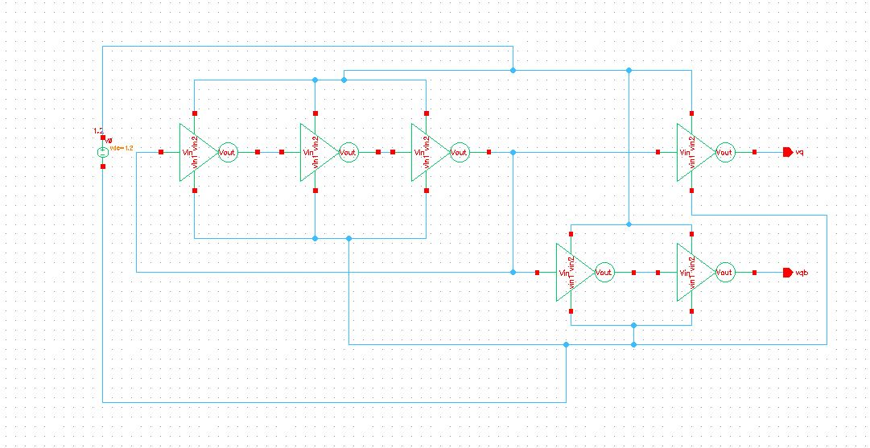

Figure 3.15: Oscillator Schematic

Transient response of oscillator is shown in Figure 3.16. These signals represent two clock signals. The oscillator frequency is obtained to be 648.1M Hz.



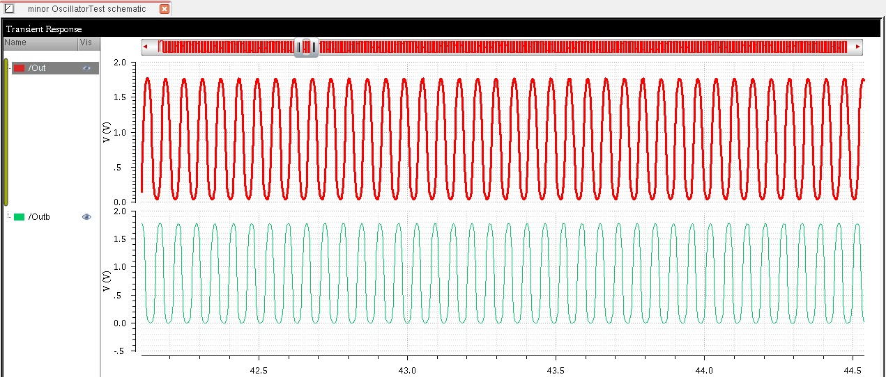

Figure 3.16: Transient response of the oscillator

# Integrated Circuit

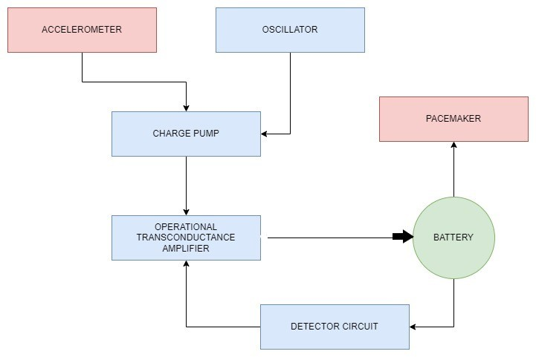

Figure 3.17: Integrated Circuit

The designed and implemented integrated circuit consists of multiple blocks which are a charge pump, operational transconductance amplifier and an oscillator as shown in Figure 3.17. The output voltage from the accelerometer is given as the input to the charge pump. The oscillator is used as the clock source to make the charge pump operational. In order to charge the battery a constant current is required.The output voltage from the charge pump is given as a differential input to the OTA, which is a voltage controlled current source. A constant current is available at the output of the OTA, which is used to charge the battery in the constant current mode.



# Simulation of Integrated Circuit

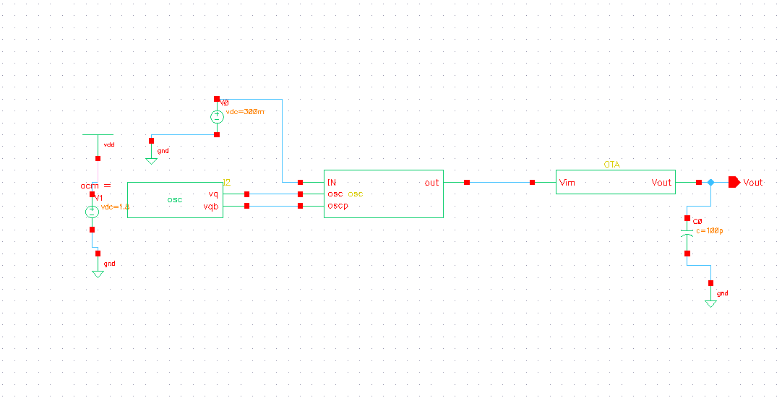

Figure 3.18: Schematic Diagram of Integrated Circuit

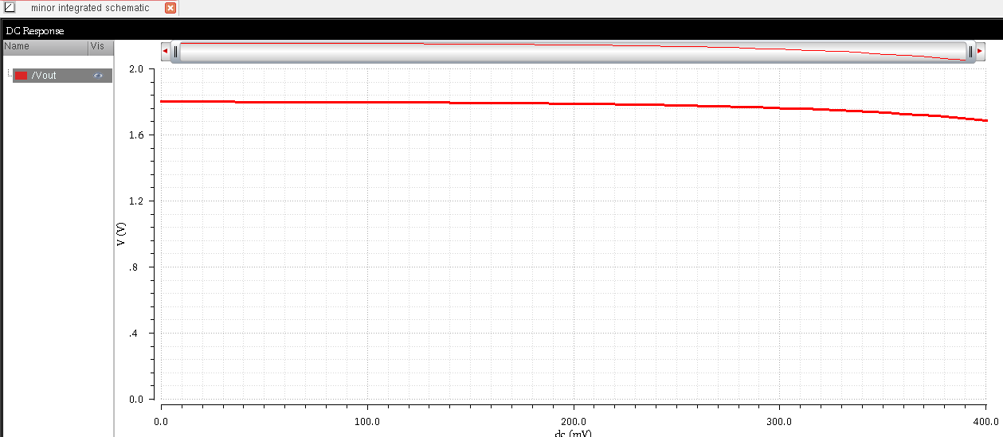

Figure 3.19: DC Analysis plot of Integrated Circuit

The integrated circuit designed using oscillator, charge pump and OTA is shown in the Figure 3.18. The cross coupled charge pump is chosen considering different charge pump topologies. The charge pump outputs 4.8 for the input of 1.2V. This value will be degraded to 4.1V as the OTA is acting as load for the charge pump in the integrated circuit. The output voltage of integrated circuit is found to be 4V. The obtained voltage is fed into the OTA. The basic function of the OTA is to convert a small input voltage into a larger output current. The OTA will produce 24.1578 *µ*A. Figure 3.20 shows



the constant current output obtained as output from Integrated Circuit. This current is almost constant. This can be used to recharge battery. Figure 3.19 represents DC analysis of the circuit for input 0.5V. The voltage at output is observed to be 1.2V.

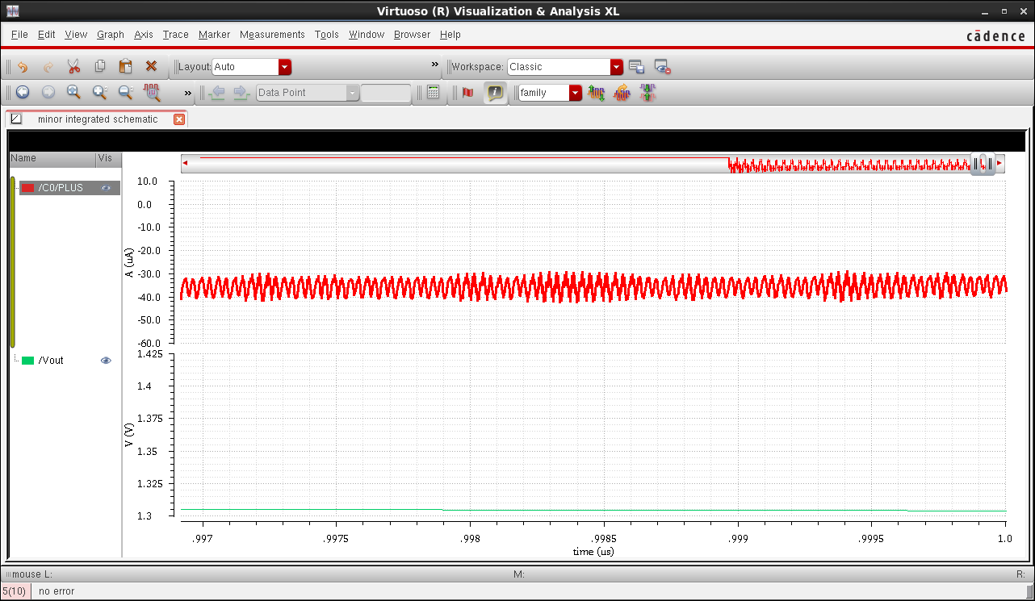

Figure 3.20: Plot of output current

The designed integrated circuit efficiently performs the charging of the battery using a charge pump and an operational transconductance amplifier as the main components. A detailed discussion of the objectives, tasks performed regarding Charge Pump, Operational Transconductance Amplifier and Oscillator and Integration of these circuits to form final circuit has been done in this chapter. Circuit design and simulation results are shown. The circuits were simulated using Cadence Virtuoso tool. The results and

outcomes of the project are discussed in next chapter.



**Chapter 4**

**Reflections**



**CHAPTER 4**

**REFLECTIONS**

This chapter discusses about the results obtained during the internship and the learn- ing outcomes of the internship is also discussed in this chapter.

# Results

The charge pump takes input voltage from a harvesting element and gives an amplified output voltage to the operational transconductance amplifier which is a voltage controlled current source. The output voltage of the cross coupled charge pump is 5.78V in no load condition and 4.8 V when a load is connected, which in this case is the operational transconductance amplifier. The output current of the operational transconductance amplifier is 24.1578 *µ*A constant current which is used for charging the battery.

# Learning Outcomes of the Project

* + - Analyze and implement knowledge from various research publications and inculcate good research papers analyzing habits.
    - Learn about the system for battery management and its importance in health crit- ical devices like implantable cardiac pacemaker.
    - Learn about various charge pump topologies, their advantages, uses, applications and limitations.
    - Study about the key features and advantages of cross coupled charge pump over other charge pumps.
    - Learn the operating principle and functions of a operational transconductance am- plifier and study of it’s output.
    - Learn to simulate various circuits and perform different analysis in Cadence Virtu- oso tool.



# BIBLIOGRAPHY

1. A. Amar, A. Kouki, and H. Cao, “Power approaches for implantable medical de- vices,” *Sensors (Basel, Switzerland)*, vol. 15, pp. 28 889–28 914, Nov. 2015. doi: [10.3390/s151128889](https://doi.org/10.3390/s151128889).
2. B. D. Valle, C. T. Wentz, and R. Sarpeshkar, “An ultra-compact and efficient li-ion battery charger circuit for biomedical applications,” in *Proceedings of 2010 IEEE International Symposium on Circuits and Systems*, 2010, pp. 1224–1227. doi: [10.1109/ISCAS.2010.5537287](https://doi.org/10.1109/ISCAS.2010.5537287).
3. S. Roy, A. N. M. W. Azad, S. Baidya, M. K. Alam, and F. Khan, “Powering solu- tions for biomedical sensors and implants inside the human body: A comprehensive review on energy harvesting units, energy storage, and wireless power transfer tech- niques,” *IEEE Transactions on Power Electronics*, vol. 37, no. 10, pp. 12 237–12 263, 2022. doi: [10.1109/TPEL.2022.3164890](https://doi.org/10.1109/TPEL.2022.3164890).
4. D. Haci, Y. Liu, S. S. Ghoreishizadeh, and T. G. Constandinou, “Key considerations for power management in active implantable medical devices,” in *2020 IEEE 11th Latin American Symposium on Circuits Systems (LASCAS)*, 2020, pp. 1–4. doi: [10.1109/LASCAS45839.2020.9069004](https://doi.org/10.1109/LASCAS45839.2020.9069004).
5. “Batteries used to power implantable biomedical devices,” *Electrochimica Acta*, vol. 84, pp. 155–164, 2012, ELECTROCHEMICAL SCIENCE AND TECHNOL- OGYState of the Art and Future PerspectivesOn the occasion of the International Year of Chemistry (2011), issn: 0013-4686. doi: https://doi.org/10.1016/j. electacta.2012.03.057.
6. B. Do Valle, C. T. Wentz, and R. Sarpeshkar, “An area and power-efficient ana- log li-ion battery charger circuit,” *IEEE Transactions on Biomedical Circuits and Systems*, vol. 5, no. 2, pp. 131–137, 2011. doi: [10.1109/TBCAS.2011.2106125](https://doi.org/10.1109/TBCAS.2011.2106125).
7. E. O. Torres and G. A. Rincon-Mora, “Electrostatic energy-harvesting and battery- charging cmos system prototype,” *IEEE Transactions on Circuits and Systems I: Regular Papers*, vol. 56, no. 9, pp. 1938–1948, 2009. doi: [10.1109/TCSI.2008.](https://doi.org/10.1109/TCSI.2008.2011578) [2011578](https://doi.org/10.1109/TCSI.2008.2011578).



1. E. Benke, A. Fehrle, J. Ollech, S. Schrampfer, and J. Franke, “Architecture and low power management of a deep-tissue medical implant system powered by human body energy harvesting,” Jan. 2020, pp. 227–234. doi: [10.5220/0009107302270234](https://doi.org/10.5220/0009107302270234).
2. A. Ballo, M. Bottaro, and A. Grasso, “A review of power management integrated circuits for ultrasound-based energy harvesting in implantable medical devices,” *Applied Sciences*, vol. 11, p. 2487, Mar. 2021. doi: [10.3390/app11062487](https://doi.org/10.3390/app11062487).
3. S.-Y. Lee, M. Su, M.-C. Liang, *et al.*, “A programmable implantable microstimu- lator soc with wireless telemetry: Application in closed-loop endocardial stimula- tion for cardiac pacemaker,” *IEEE transactions on biomedical circuits and systems*, vol. 5, pp. 511–22, Dec. 2011. doi: [10.1109/TBCAS.2011.2177661](https://doi.org/10.1109/TBCAS.2011.2177661).
4. S. Boisseau, G. Despesse, and B. A. Seddik, “Electrostatic conversion for vibra- tion energy harvesting,” in *Small-Scale Energy Harvesting*, M. Lallart, Ed., Ri- jeka: IntechOpen, 2012, ch. 5. doi: [10.5772/51360](https://doi.org/10.5772/51360). [Online]. Available: [https:](https://doi.org/10.5772/51360)

[//doi.org/10.5772/51360](https://doi.org/10.5772/51360).

1. E. Hamadaqa, A. Abadleh, A. Mars, and W. Adi, “Highly secured implantable medical devices,” in *2018 International Conference on Innovations in Information Technology (IIT)*, 2018, pp. 7–12. doi: [10.1109/INNOVATIONS.2018.8605968](https://doi.org/10.1109/INNOVATIONS.2018.8605968).
2. P. Anacleto, P. Mendes, E. Gultepe, and D. Gracias, “Micro antennas for im- plantable medical devices,” in *2013 IEEE 3rd Portuguese Meeting in Bioengineering (ENBENG)*, 2013, pp. 1–4. doi: [10.1109/ENBENG.2013.6518405](https://doi.org/10.1109/ENBENG.2013.6518405).
3. Y. Ben Fadhel, S. Ktata, S. Rahmani, and K. Al-Haddad, “Used methods to wire- lessly powered implantable medical devices,” in *2016 17th International Confer- ence on Sciences and Techniques of Automatic Control and Computer Engineering (STA)*, 2016, pp. 475–480. doi: [10.1109/STA.2016.7952035](https://doi.org/10.1109/STA.2016.7952035).
4. J. I. Al-Nabulsi, H. A. Al-Doori, and N. T. Salawy, “Human motion to recharge im- plantable devices,” in *2017 10th Jordanian International Electrical and Electronics Engineering Conference (JIEEEC)*, 2017, pp. 1–5. doi: [10.1109/JIEEEC.2017.](https://doi.org/10.1109/JIEEEC.2017.8051413) [8051413](https://doi.org/10.1109/JIEEEC.2017.8051413).
5. L. Andia, R.-F. Xue, K.-W. Cheng, and M. Je, “Closed loop wireless power trans- mission for implantable medical devices,” in *2011 International Symposium on In- tegrated Circuits*, 2011, pp. 404–407. doi: [10.1109/ISICir.2011.6131982](https://doi.org/10.1109/ISICir.2011.6131982).



1. L. Wong, S. Hossain, A. Ta, *et al.*, “A very low power cmos mixed-signal ic for implantable pacemaker applications,” in *2004 IEEE International Solid-State Cir- cuits Conference (IEEE Cat. No.04CH37519)*, 2004, 318–530 Vol.1. doi: [10.1109/](https://doi.org/10.1109/ISSCC.2004.1332722) [ISSCC.2004.1332722](https://doi.org/10.1109/ISSCC.2004.1332722).
2. D. Newaskar and B. P. Patil, “Wireless charging of aimds-compensation circuits,” in *2020 International Conference on Computational Performance Evaluation (ComPE)*, 2020, pp. 173–177. doi: [10.1109/ComPE49325.2020.9200101](https://doi.org/10.1109/ComPE49325.2020.9200101).
3. A. Ballo, A. D. Grasso, and G. Palumbo, “A review of charge pump topologies for the power management of iot nodes,” *Electronics*, vol. 8, no. 5, 2019, issn: 2079-9292. [Online]. Available: <https://www.mdpi.com/2079-9292/8/5/480>.
4. H. Dadhich, V. Maurya, K. Verma, and S. Jaiswal, “Design and analysis of dif- ferent type of charge pump using cmos technology,” in *2016 International Con- ference on Advances in Computing, Communications and Informatics (ICACCI)*, 2016, pp. 294–298. doi: [10.1109/ICACCI.2016.7732062](https://doi.org/10.1109/ICACCI.2016.7732062).
5. V. Mudeng, Y. T. Kusuma Priyanto, H. Wicaksono, V. A. Kusuma, and M. Muntaha, “Design of five stages cockroft-walton with passive filter,” in *2019 6th International Conference on Electric Vehicular Technology (ICEVT)*, 2019, pp. 393–396. doi: [10.1109/ICEVT48285.2019.8993983](https://doi.org/10.1109/ICEVT48285.2019.8993983).
6. D. Chauhan and L. Gupta, “Design of current mirror and telescopic ota using 0. 18µm technology,” 2016.
7. D. El-Damak and A. P. Chandrakasan, “A 10 nw–1 µw power management ic with integrated battery management and self-startup for energy harvesting appli- cations,” *IEEE Journal of Solid-State Circuits*, vol. 51, no. 4, pp. 943–954, 2016. doi: [10.1109/JSSC.2015.2503350](https://doi.org/10.1109/JSSC.2015.2503350).
8. P. Valdastri, A. Menciassi, A. Arena, C. Caccamo, and P. Dario, “An implantable telemetry platform system for in vivo monitoring of physiological parameters,” *IEEE Transactions on Information Technology in Biomedicine*, vol. 8, no. 3, pp. 271– 278, 2004. doi: [10.1109/TITB.2004.834389](https://doi.org/10.1109/TITB.2004.834389).